Final Project:

Upon creating VM in virtual and intalled SQL server and SSMS in it as well, PFB snip

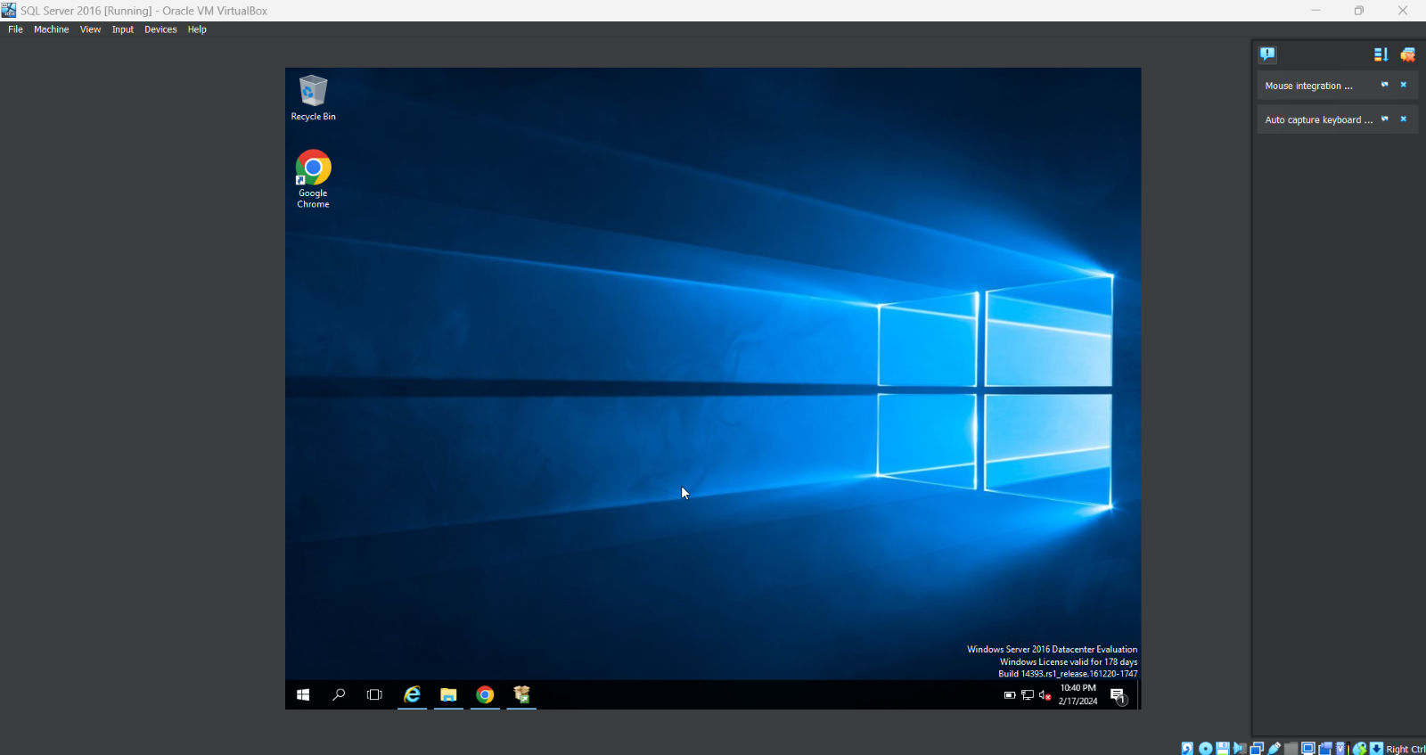

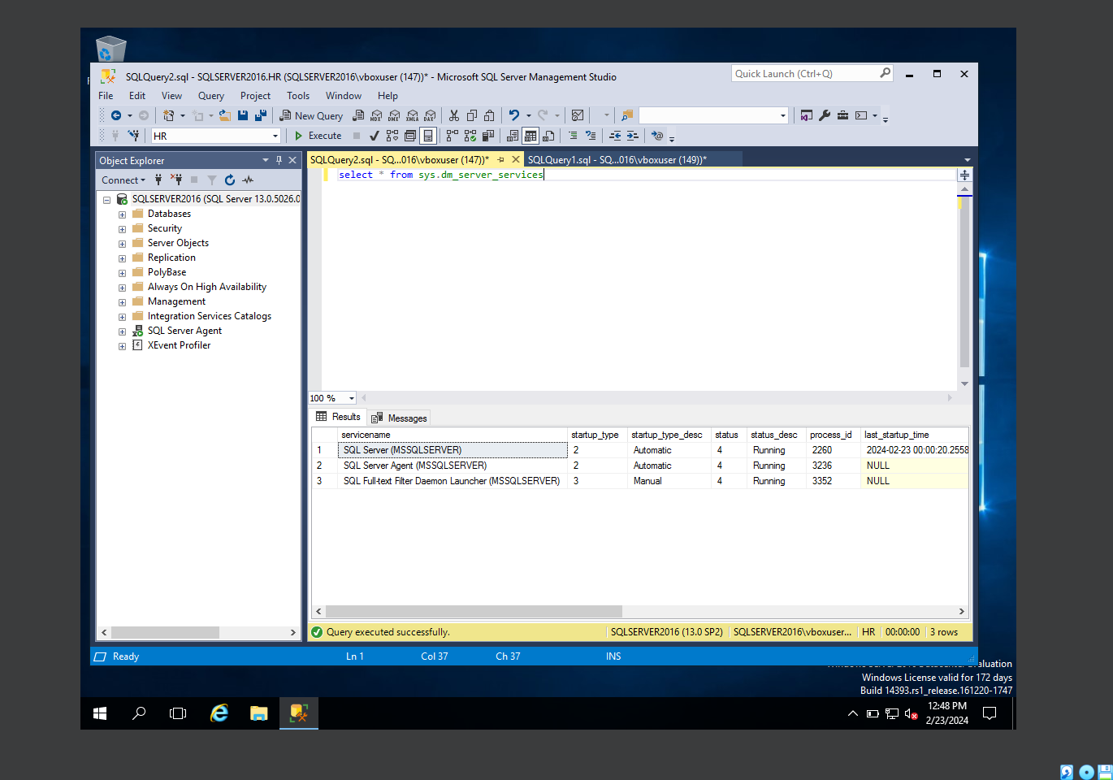

We created a sample database ‘HR’ and create a table sample table ‘ Employee’ PFB snip

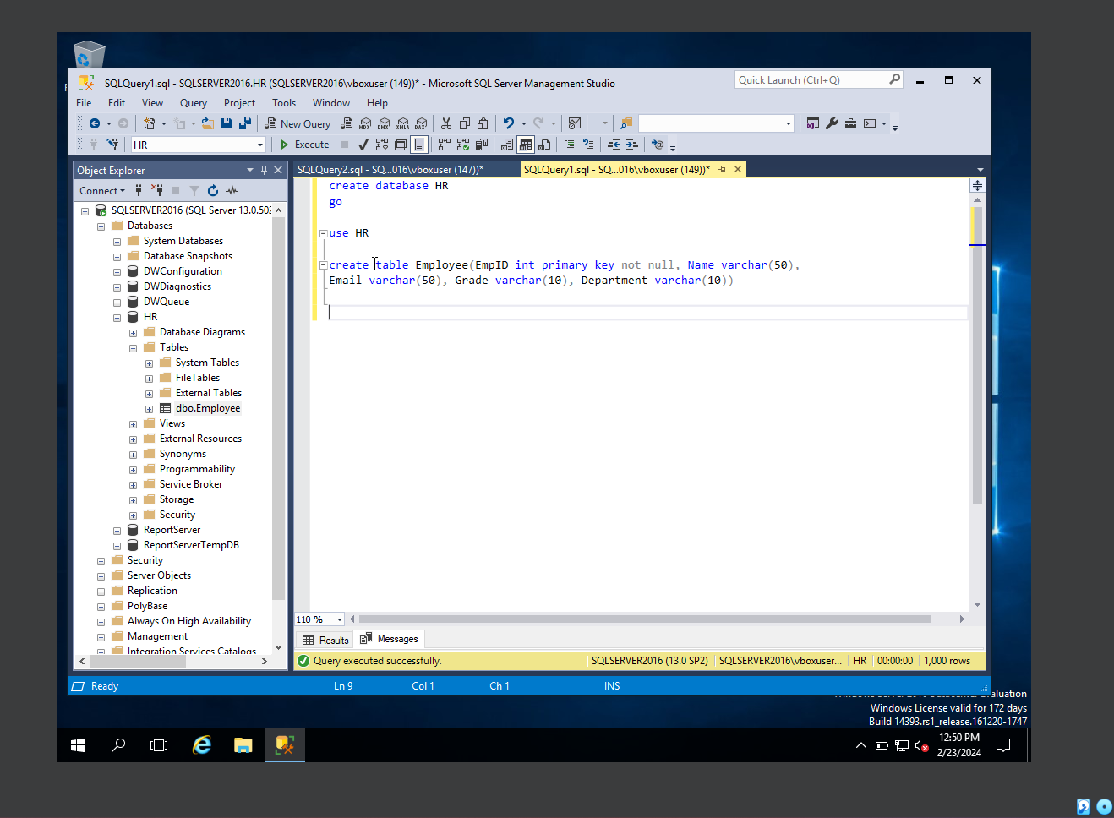

Now we have inserted some random data into table about 1000 rows, PFB snip

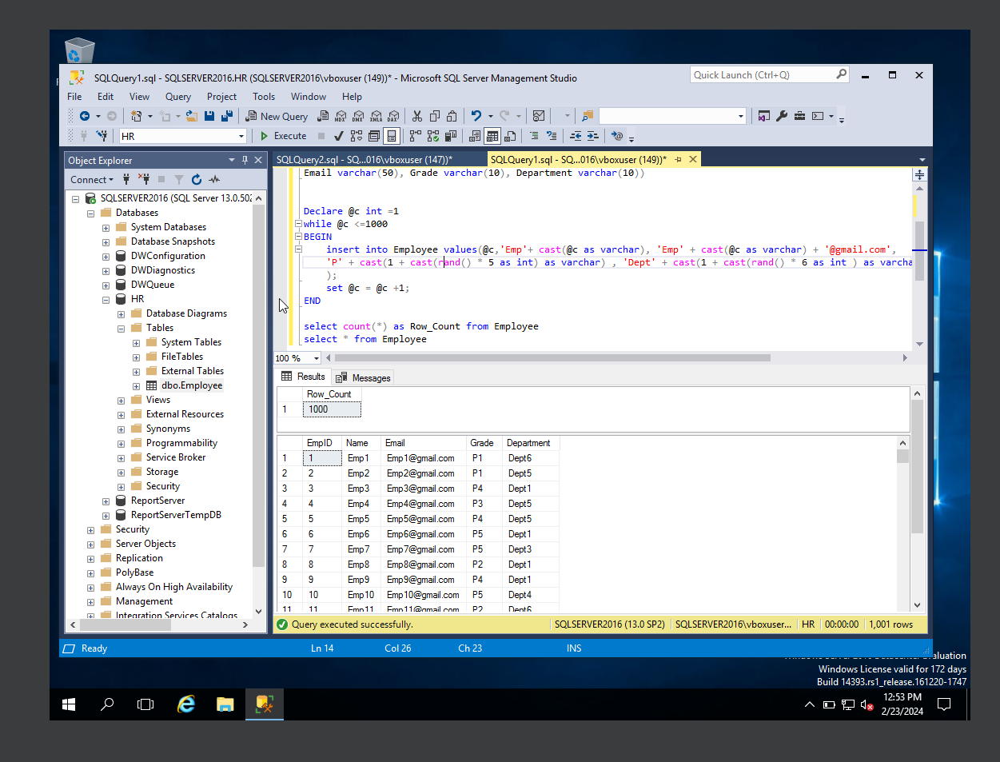

Performing Administrative function into the table,

There are many admin functions you can perform in SQL server, most of them depending upon the requirement. Also, we need to understand implication of those admin functions before executing them in Prod environment.

Here, we can show simple admin functions with example below,

1. backup database:

We can take backup of DB to a location

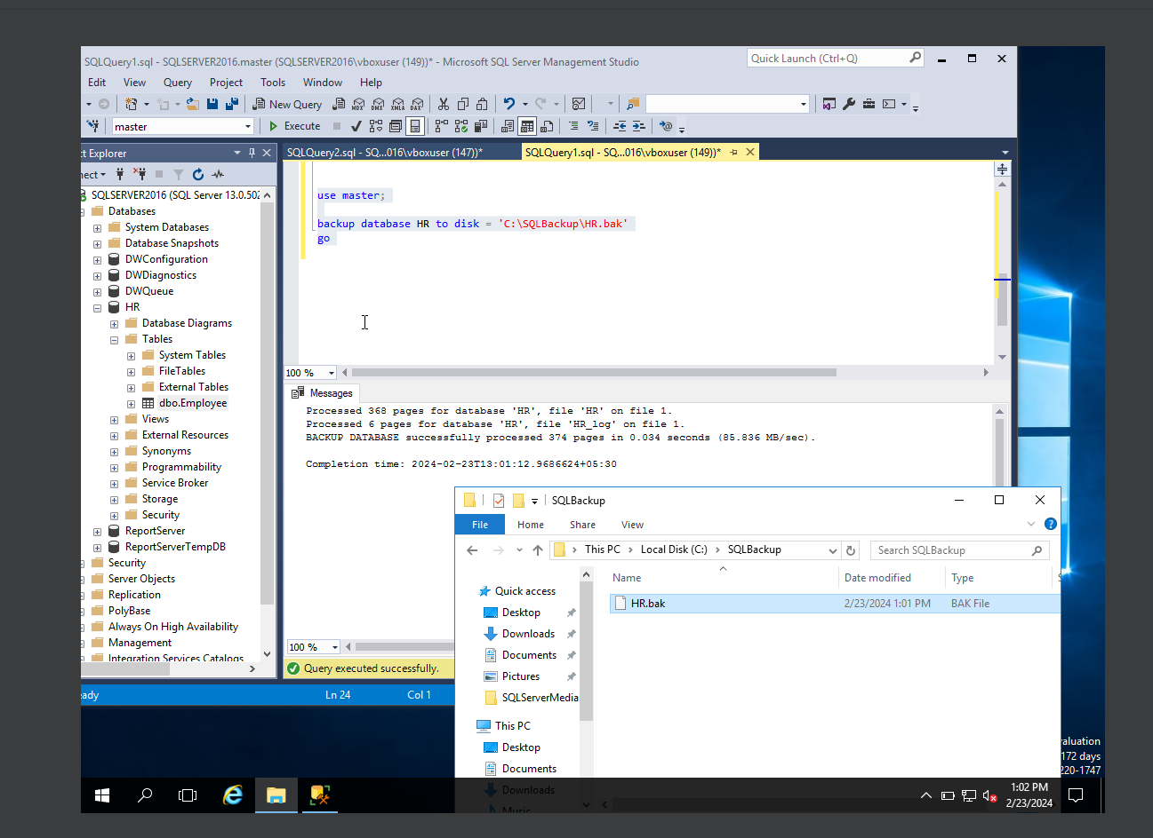

1. Restore Database;

Similarly, we can perform a restoration of database if we have backup file a DB, we take backup file taken from above example

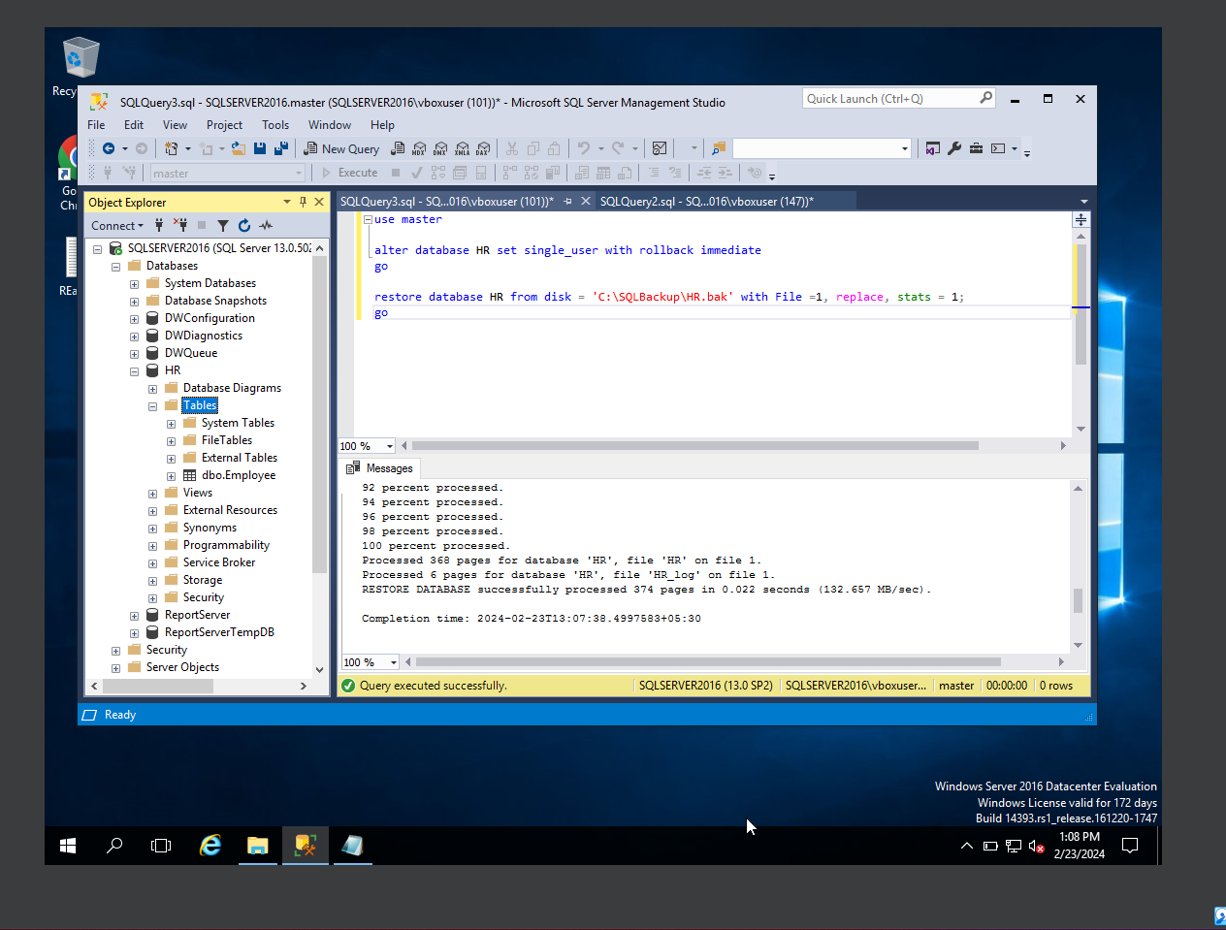

1. Shrink database command;

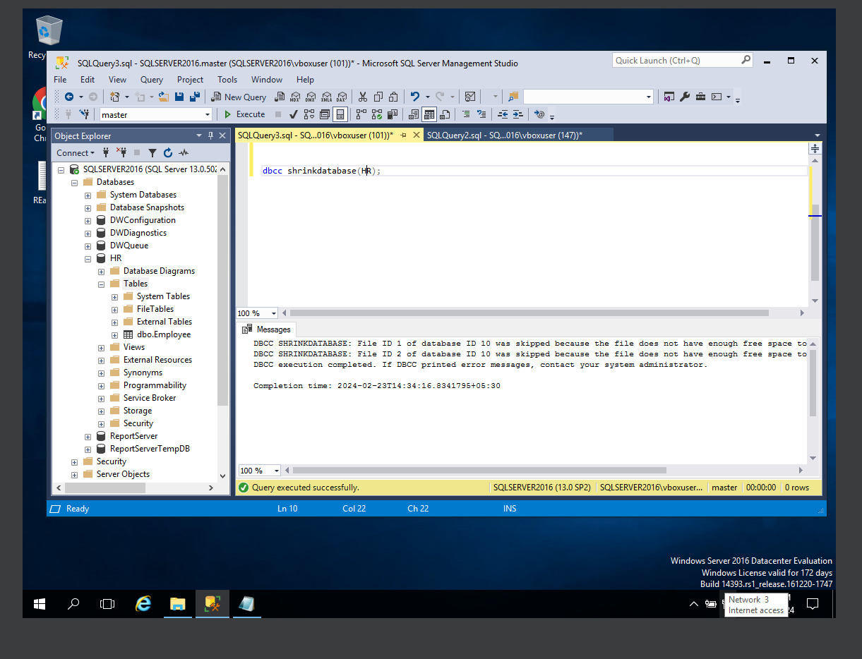

This command will release the free space if available in the data file

1. Checkdb command;

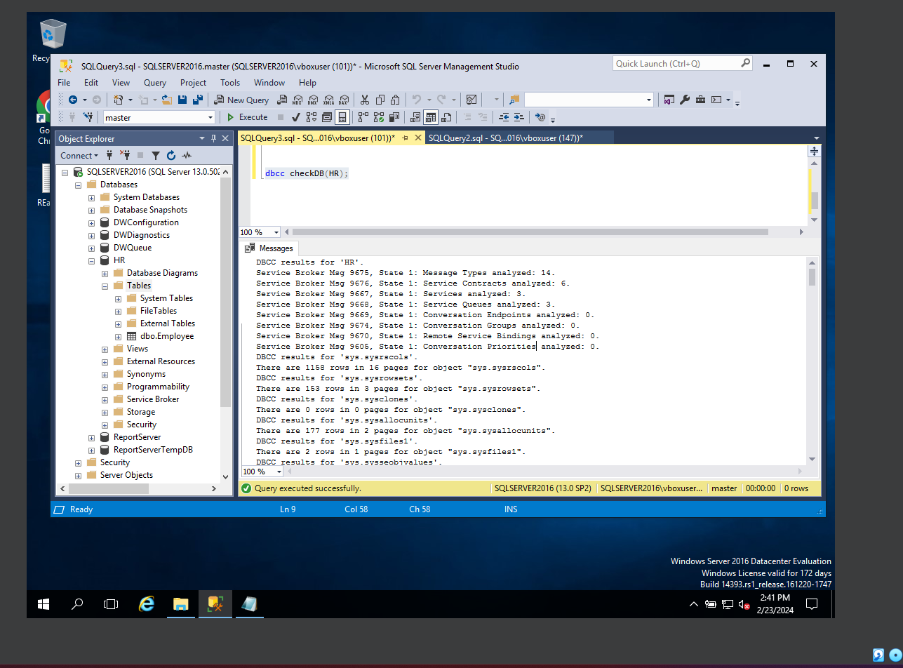

This query/ command will check if there are any errors / issue in database. Also the database integrity, consistency to data present in the DB as well.

1. Renaming the Database name;

We can rename the database using teh query shown below.

